Christopher Montani, comments by Chester Moses

Software Development

Bug Report

Bug Report (March Madness)

1. Please make the message look more appealing (Nit Picking I know), Ex: No user with the Username “Test” exists. A new account has been created.

We worked hard on this lets make it look appealing as well

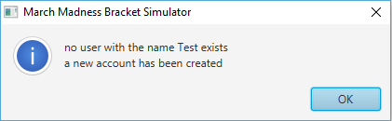

(Done)

1. When Filling out divisional brackets (East, West etc) the clear button has no functionality



(Mostly done – does not work on Final Four)

1. Make this look Grammatically correct, Capitalization/punctuation

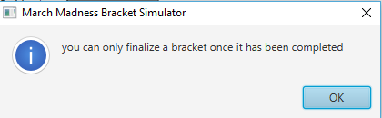

(Done)

1. Change the “back” button to read “Back”

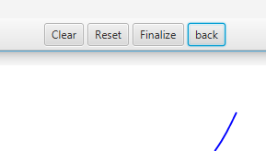

(Done)

1. Resize the size of the GUI window to be able to handle the entire size of a full bracket on launch

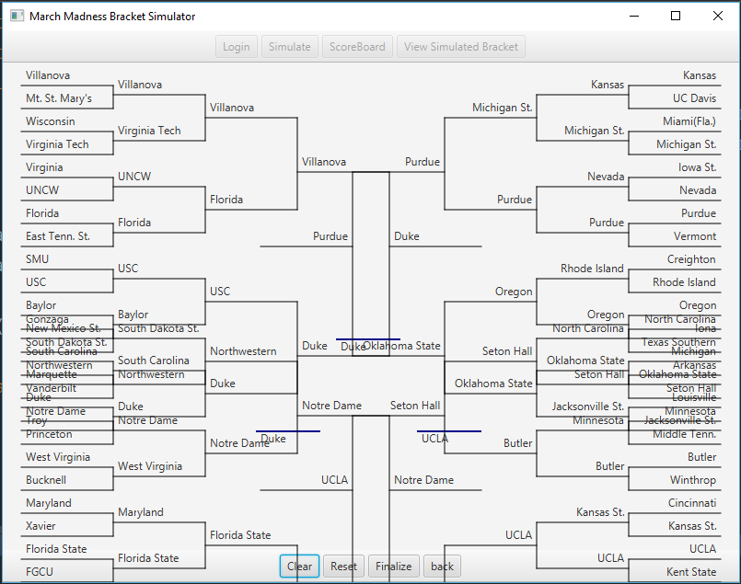

(done)

1. Make the individual bracket sizes larger so the School names will fit comfortably

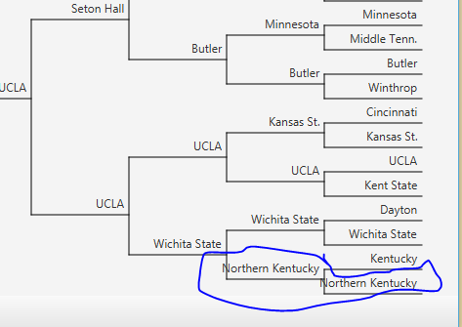

1. After selecting Simulate I am navigated to the scoreboard window but there is no scores only dummy data

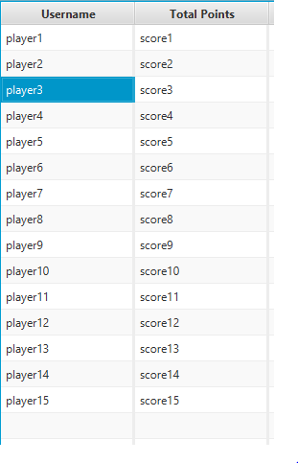

(done)

1. The user has no way of knowing which teams they selected were correct predictions, Highlight the correctly predicted school names in green.

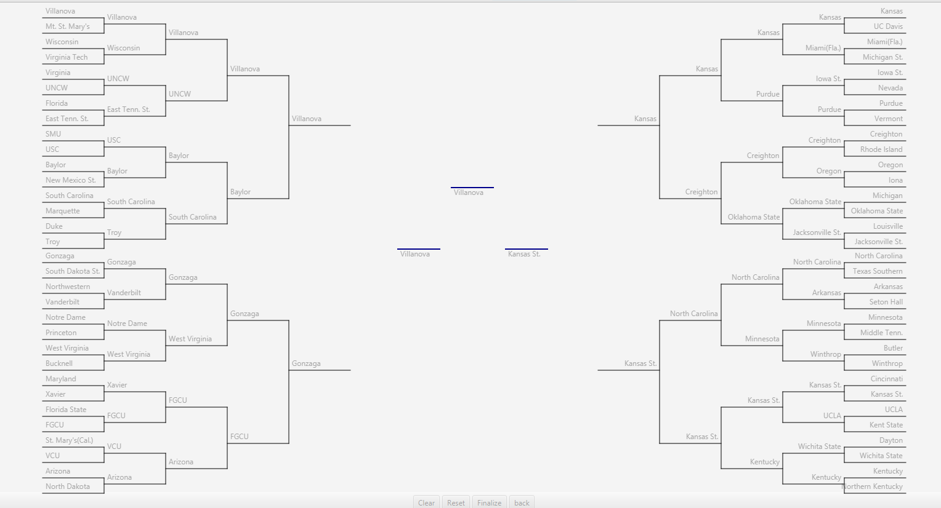

1. Make the table “Read-Only” so the user can not manipulate data

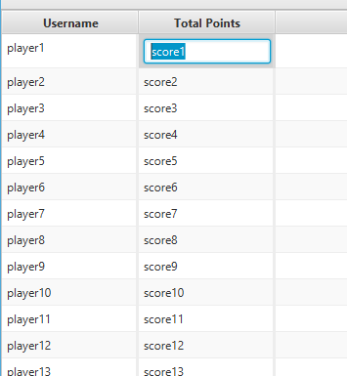

(done)

1. Let the Scoreboard pane be sortable as of now it does not allow this functionality

(done – you can sort by username or by score!)

1. There is no way for the user to view any college information about certain schools. Where is this being displayed?

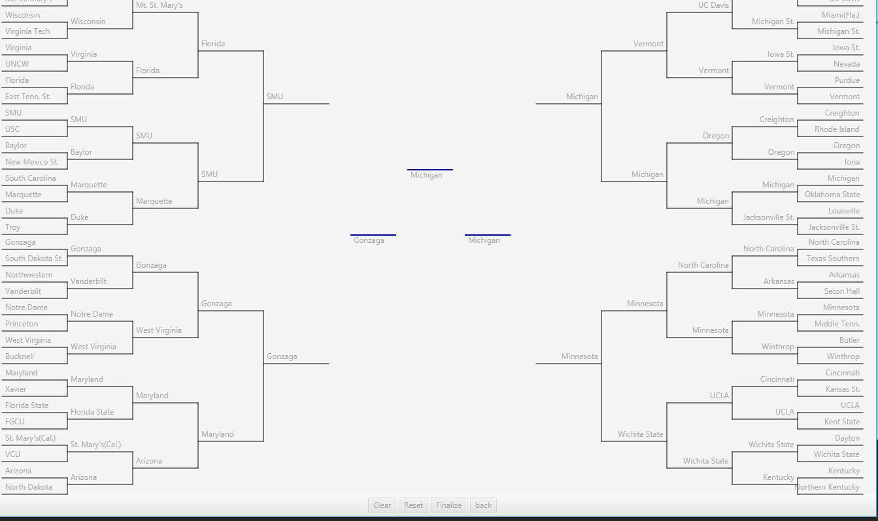

(done)

1. Maybe add a “Log-Out” button

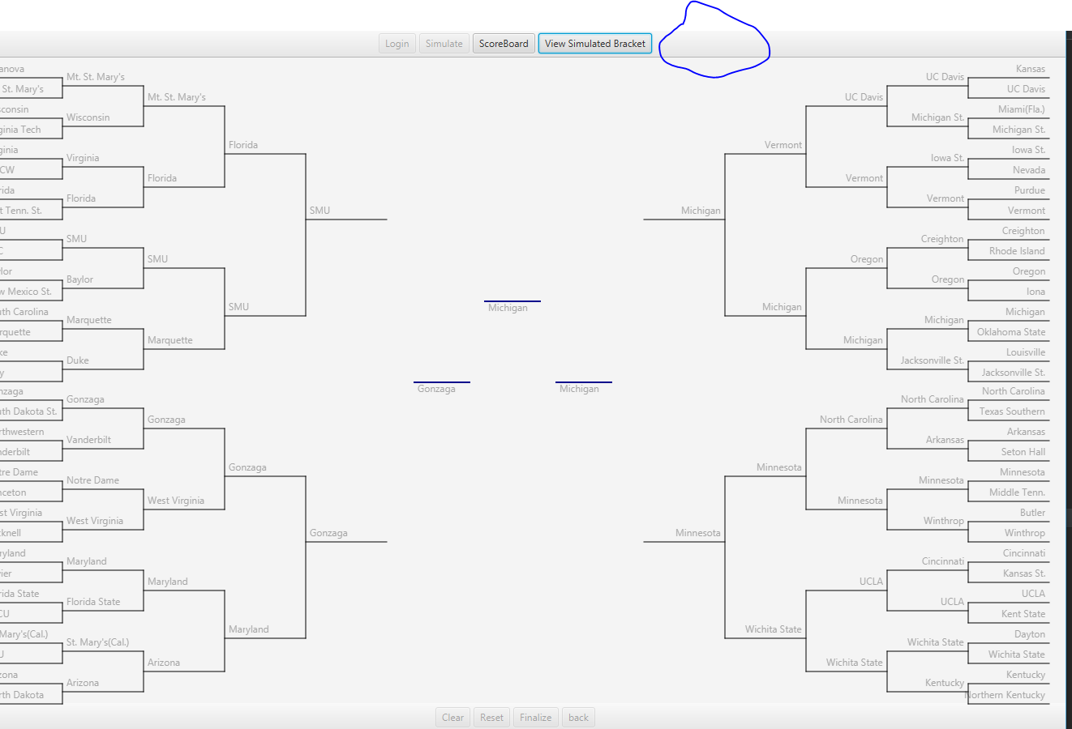

**16) Finalize button pressed, no indication of what to do or what comes next**

**17) Login button on this screen doesn’t make sense, logout button maybe?**